
AMERICAN INTERNATIONAL UNIVERSITY-BANGLADESH (AIUB)
Faculty of Engineering
Bachelor of Science in Electrical and Electronic Engineering (EEE)
BAE 2101: Computer Aided Design and Drafting
Course Name: | COMPUTER AIDED DESIGN & DRAFTING | Course Code: | BAE 2101
Semester: | Fall 2023-2024 | Section: | D (Group:05)
Faculty: | Mehedi Hasan | OEL/Project | 1
Assessment: | OEL (CO2 & CO3), POI: P.e.1.C6
Submission Deadline: | 05.12.2023

OEL REPORT ON
Title: Design a civil plan with electrical fitting & fixture according to BNBC of a Hospital floor using AutoCAD
Submitted By
 | ID | Student Name | Cotribution | Marks
1 | 23-51759-2 | BHUIYAN, MD. ASHIF FAIHAD SHUVO | Quality Control
2 | 23-51773-2 | PAUL, NILOY | Report Writing
3 | 23-52255-2 | GHOSH, POLIN | Drawing
4 | 23-52368-2 | SHOKAL, MD. RAKIB HASAN | Drawing Plan
5 | 23-52773-2 | SARKER, TAUHID | Drawing and Drafting
Date of Submission: 05.12.2023
**Title**
Design a civil plan with electrical fitting & fixture according to BNBC of a Hospital floor using AutoCAD

**Objectives**
The civil plan of a restaurant floor will be designed in AutoCAD with Electrical Fittings according to the Bangladesh National Building Code in this experiment.

**Experiment to Solve**
1.An ideal Hospital floor plan of approximately 6000 square feet (total) is to be drawn using AutoCAD software.
2. The fittings for the civil plan, consisting of necessary electrical fittings, are to be drawn applying BNBC

**Introduction**
The design and planning of civil structures, particularly in the context of commercial establishments like restaurants, play a crucial role in ensuring safety, functionality, and compliance with building codes. This experiment aims to create a comprehensive civil plan for a restaurant floor using AutoCAD, incorporating essential electrical fittings and fixtures in accordance with the Bangladesh National Building Code (BNBC). AutoCAD, a widely used computer-aided design (CAD) software, facilitates precision and efficiency in drafting architectural plans.

**Objectives**
The primary objective of this experiment is to design a civil plan for a restaurant floor, covering approximately 6000 square feet, utilizing AutoCAD. Additionally, the plan will integrate electrical fittings in compliance with the Bangladesh National Building Code. The Bangladesh National Building Code serves as a vital reference to ensure that construction and design adhere to safety standards and regulations.
**Experiment to Solve**

1. Ideal Hospital Floor Plan: The first aspect of the experiment involves drawing an ideal hospital floor plan using AutoCAD. This process encompasses the creation of a layout that optimizes space utilization, promotes efficient workflow, and meets the specific requirements of a healthcare facility.

2. Electrical Fittings According to BNBC: The second part focuses on incorporating necessary electrical fittings into the civil plan. This includes the placement of various fixtures such as fans, lights, tube lights, televisions, and electrical sockets. The design process will strictly adhere to the guidelines outlined in the Bangladesh National Building Code to ensure electrical safety and compliance.

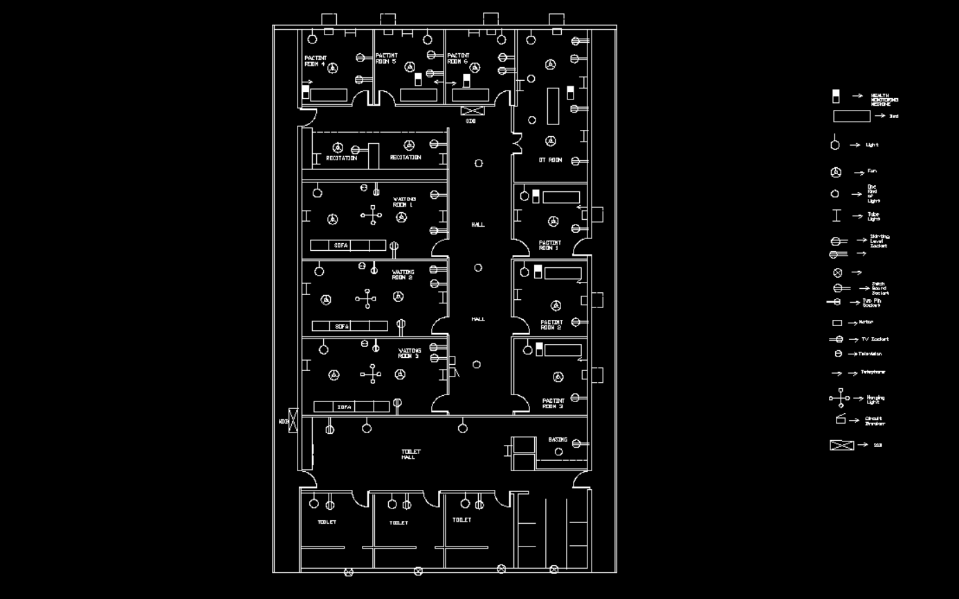
**CAD Drawing**

**Symbols for Fittings and Fixture Layout:**

The following symbols will be utilized in the plan to represent different electrical fittings and fixtures:

- F – Fan
- L – Light
- T – Tube Light
- K – One Kind of Light
- TV – Television
- TE – Telephone
- M – Motor
- CH – Hanging Light
- CB – Circuit Breaker
- SB – Switch Board
- SS – Switch Board Socket
- ST – Two Pin Socket
- SL – Skirting Level Socket
- TS – TV Socket
- 15_1 – 3 Pin Socket (15 A)
- TJB – Telephone Junction Board
- AJB – Antenna Junction Board
- C1, C2, ... – Number of Cables
- Health monitoring machine

**Discussion**

The discussion phase will involve a detailed analysis of the design choices made during the experiment. This includes considerations for spatial layout, electrical system integration, and compliance with the BNBC. Potential challenges faced during the design process and their resolutions will also be discussed. The significance of adhering to building codes in ensuring the safety and functionality of the Hospitalfloor will be emphasized.

**Conclusion**

In conclusion, this experiment aims to demonstrate the practical application of AutoCAD in designing a civil plan for a Hospital floor, incorporating essential electrical fittings in alignment with the Bangladesh National Building Code. The experiment not only highlights the technical aspects of the design process but also underscores the importance of regulatory compliance in ensuring the safety and sustainability of commercial structures.

**Reference**

The design and implementation of this experiment are guided by the principles outlined in the Bangladesh National Building Code. Additionally, AutoCAD documentation and relevant literature on architectural and electrical design serve as key references in achieving a comprehensive and compliant civil plan.Also collect from CAD Lab Report.
1. Kristen S. Kurland, “AutoCAD 2004, 2D Training Manual”.
2. Bob McFarlane, “Beginning AutoCAD 2004”.
3. David Byrnes and Mark Middlebrook, “AutoCAD 2007 For Dummies”

